Cover Page

Title: Breathing Numbers: What PM2.5 Data Reveals About Air Quality

Author Names: Shuvam Maity, Shreeja Banerjee

Affiliations: M.Sc. Data Science 2nd Year Student

Email id: shuvamofficial40@gmail.com , shreejabanerjee.datascience@gmail.com

Abstract
“Breathing Numbers” focuses on the changing patterns of urban air pollution by PM2.5 concentration in Kolkata from 2022 to 2024, based on data from the Central Pollution Control Board. The analysis places Kolkata in a broader national framework, illustrating that although its average AQI(~106.37) is lower than Delhi’s, it is still much worse than that of coastal cities, often reaching the Moderately Polluted level. An STL (Seasonal-Trend decomposition using LOESS) analysis discloses a very high Seasonal Strength (0.835) and Trend Strength (0.927), thereby establishing that the PM2.5 in Kolkata is dominated by meteorological factors—reaching a peak in late January and during the monsoon season—along with a steady trend. Intra-city variations are revealed to be extremely high by station-wise boxplots, with green areas like Rabindra Sarobar having the cleanest air, while Bidhannagar and Ballygunge having high variability and extreme pollution levels above 200 µg/m³. The results clearly point to serious public health concerns due to regular violations of WHO standards, thus suggesting measures like Airshed Management, Miyawaki micro-forests at traffic congestion points.
Keywords: Air Quality Index(AQI); PM2.5; Urban Air Pollution; Public Health Impact; Environmental Data Analysis

Breathing Numbers: What PM2.5 Data Reveals About Air Quality

Introduction
Pollution is the presence of undesirable, hazardous substances in the various elements of nature that cause health problems in living beings who come in contact with the adulterated environment .The topic of interest of this study will be limited to air pollution. Firstly,we will compare the AQI (Air Quality Index) , a composite index to determine the level of Air Pollution in an area, of different cities of India belonging to different geographies. As residents of Kolkata , it is our curiosity as well as concern for the city that has been a primary motive for indulging in this study. Further steps in this study will involve the most potent pollutant in Kolkata which not only surpasses the safe limits oftentimes but whose inclusion is most detrimental. Finally, we will analyse this pollutant’s presence in the skies of the City Of Joy in hopes of possibly uncovering certain patterns. All of the above mentioned studies will be conducted using data spanning from 2022-2024.
Data Description:
There are 1096 observations in the dataset. Our data has 25 columns including Timestamp, AQI, PM2.5, PM10, CO, NO₂ etc. We have 3 years of data from 2022-2024. We have 2 columns with null values which we dropped. For the overall citywise data, there are no missing values. For sensor downtime in station wise data, we have almost less than 0.3% missing values which is also not in consecutive days and is scattered all over the data. We can safely drop these values (Kebalepile(2024)).
Data Source: CENTRAL POLLUTION CONTROL BOARD (CPCB)
https://airquality.cpcb.gov.in/ccr/#/caaqm-dashboard-all/caaqm-landing/aqi-repository

AQI:
Air Quality Index (AQI) is a numerical indicator used to convey the quality of air by the government to the general public. Air quality deteriorates with an increase in the concentration of pollutants. The Air Quality Index represents the severity of pollution for ordinary people.There are eight major pollutants to be taken into account for AQI calculation, viz. particulate matter (PM10 & PM2.5), carbon monoxide (CO), ozone (O3), nitrogen dioxide (NO2), sulfur dioxide (SO2), ammonia (NH3), and lead (Pb) (World Health Organization(2021)).
Comparison of AQI of different cities of India:
We begin by extracting daily AQI data at the city level for the time period 2022-2024 of different cities of India separately. Chennai,Delhi,Guwahati,Kolkata,Mumbai are chosen as together they are sufficient to encompass the vast geographic expanse of the country .Our motivation is to check the level of Air Pollution in these major cities.
For each city, the average AQI is calculated by simple arithmetic mean. This is calculated from 2022 to 2024 and plotted. The plot achieved is given below:
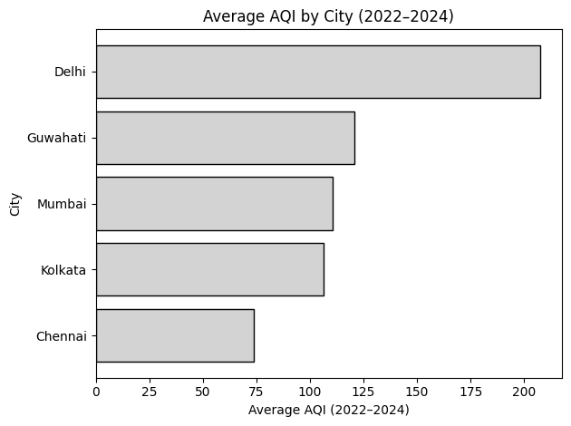
Figure 1: Barplot of average AQI of different cities from 2022-2024 in India
All of the cities have considerably high means,essentially implying the extent of pollution. Kolkata faces a mean AQI of 106.37.
Henceforth,the emphasis of our study would be on the air quality in Kolkata.

Identification of the most potent pollutant
We see that a number of pollutants are collectively responsible for the degradation of air quality in Kolkata.
Our objective is to identify the pollutants which surpass their respective safe limits quite a number of times and then select the one with the highest contribution in terms of causing adverse health outcomes.
We obtained Pearsonian correlation coefficient between AQI and other pollutants and found that PM2.5 is the most correlated pollutant for AQI with correlation 0.98.
Now, we can proceed with PM2.5 as it is the most potent pollutant and study it to uncover its patterns.

PM2.5
This kind of particulate matter includes all atmospheric aerosols with a maximum diameter of 2.5 micrometers, hence the 2.5 designation. Due to the fine nature of these particles and their inherent ability to penetrate directly into our bloodstream, PM2.5 is considered to be the most dangerous kind of pollutant that does the most damage to human health.(World Health Organization(2021))
According to the WHO guidelines for 2021,the recommended daily limit of PM2.5 in the air is 15μg/m³. (World Health Organization(2021))
From the data, it is observed that AQI surpasses the magnitude of 100μg/m³ on 438 days.Further analysis indicates that PM 2.5 concentration was higher than safe limits on each of those 438 days.
Here on, we focus our analysis on PM 2.5 levels in Kolkata (2022-2024).
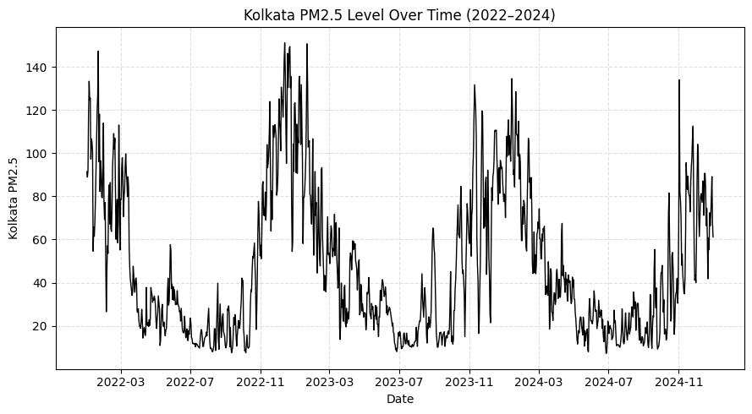
Figure 2: PM2.5 level of Kolkata Over Time(2022-2024)
Kolkata's PM2.5 data from 2022 to 2024 does display a definite trend with very high levels of air pollutants during the winter season (November to January) and low levels during the monsoons (June to September). The levels of air pollutants have also surpassed the safe levels during the winter seasons, which could be attributable to certain meteorological factors. Yet, there are no indications of long-term improvements that could be attributed to any specific actions taken for improved air standards.

Statistical Decomposition of PM2.5 in Kolkata (2022–2024)

From Figure 2, we can see many daily fluctuations in the entire data, but daily fluctuations are not our concern. Here, we want to see the general trend and seasonal variation, which represents the yearly variations.
Seasonal–Trend decomposition using LOESS (STL) was applied to the PM2.5 data of Kolkata to separate long-term trends, seasonal variability, and short-term irregular fluctuations. STL is a non-parametric decomposition approach that uses locally weighted regression and does not impose rigid functional or distributional assumptions, making it well suited for complex environmental time-series data. This decomposition enables clearer interpretation of long-term pollution trends and more reliable identification of anomalous pollution events.(Borchers-Morgan(2024))

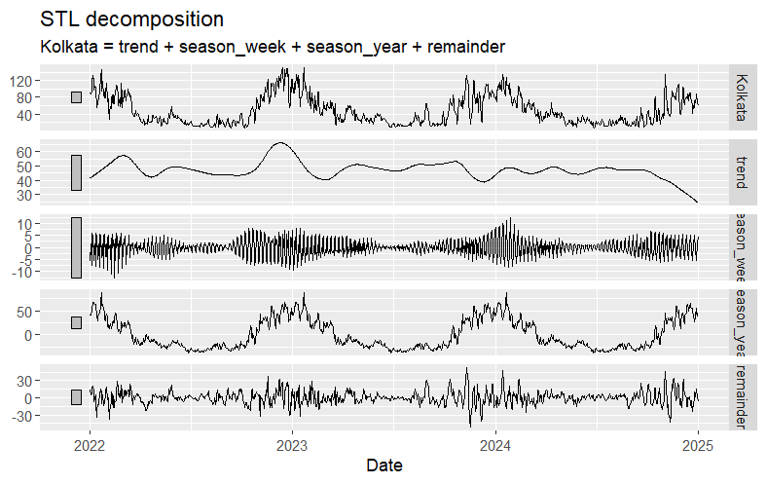
Figure 3: Visual representation of STL Decomposition of Kolkata(2022-2024)
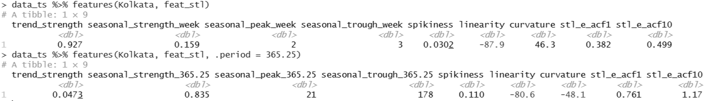
Figure 4: STL decomposition feature metrics for using weekly and annual seasonal periods
Weekly features:
Here, we considered weekly data for statistical decomposition.
We can see a high trend removing the seasonality and the trend is non-linear in nature and the curvature is very high and upward bending that is convex. The weekly seasonal strength is very weak and on an average Tuesday hits the peak and Wednesday hits the lowest PM2.5 levels. Sudden spikes are almost negligible. Autocorrelation of STL residuals shows that residuals are not white noise.

Annual features:
Here, we considered annual data for statistical decomposition.
Results show high seasonality and a very low trend in the PM2.5 emmisions. The trend is non-linear in nature and the curvature is downward bending or concave. There are sudden spikes present. The high pollution day is generally 21st January and the low pollution day is generally June 26-27. Autocorrelation of STL residuals shows that residuals are not white noise.

Intra-City Analysis: PM2.5 Distribution across Kolkata
After observing the overall PM2.5 pattern of Kolkata ,now, we will check intra city pollution levels of various areas of Kolkata. It will give us more insights about the PM2.5 level in various parts of Kolkata.
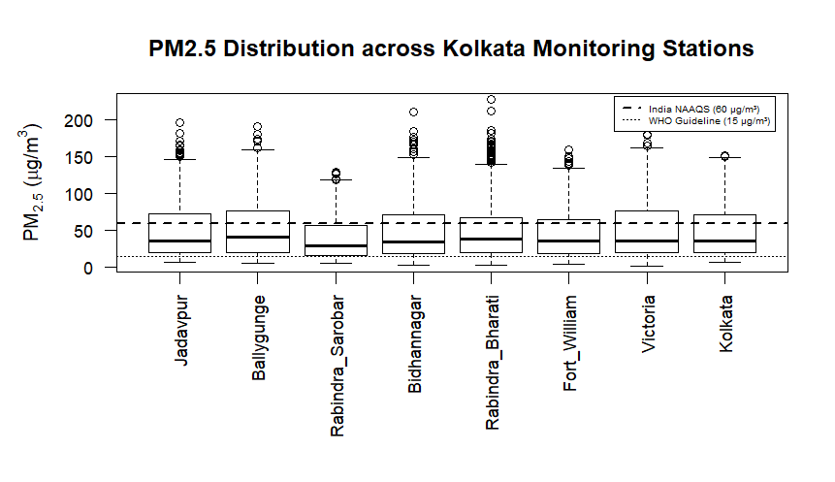
Figure 5: Boxplot of all the stations in Kolkata including Kolkata itself
The plots also reveal that the median values at most monitoring stations were already very close to or even below the 60 µg/m³ standard set by India but well above the 15 µg/m³ standard set by WHO. Rabindra Sarobar is identified to have the least particulate matter concentration and the least variability, protected by green spaces and water bodies. On the other hand, Victoria, Bidhannagar, and Ballygunge have a slightly higher upper quartile, indicating moderate levels frequently observed at these stations. Outliers for individual stations at values greater than 200 µg/m³ reveal how no area is protected during extreme pollution events.

Table 1: Summary of Station Dynamics
Station | Median PM2.5 | Spread/Volatility | Risk Level
Rabindra Sarobar | Lowest (~30) | Very Low | Minimal (for Kolkata)
Fort William/Bidhannagar | Moderate (~30-35) | Moderate | Regular exposure
Victoria / Rabindra Bharati / Jadavpur | High (~35-40) | High | Frequent unhealthy days
Ballygunge | Highest (greater than 40) | Highest | Extreme risk during peaks

Strategic Suggestions for a "Cleaner Kolkata"

1. The "Airshed" Management Strategy
In our STL model we have observed high trend strength (0.927) which clearly indicates a persistent baseline pollution. This matches with the findings of the World Bank’s Airshed Report (2023) which suggests that a significant portion of Kolkata’s PM2.5 is transboundary in nature, originating from the broader Indo-Gangetic Plain rather than purely local sources.

- Regional Coordination: The air quality cannot be managed by the Kolkata Municipal Corporation(KMC) alone. A unified “Airshed” regulatory body should be formed to monitor all air quality related activity and coordinate with Howrah, Hooghly, and North 24 Parganas regarding industrial and crop-burning regulations.
- Buffer Zones: “Green Belts” can be created at city borders to safeguard the city from the incoming outside industrial pollutants from the neighbouring districts.

2. Combating "Secondary Aerosols":
As also suggested in the station-wise boxplot chart provided in Fig. 7, during the winters, extreme values for PM2.5 have been reported at even more green stations like Victoria Memorial and Rabindra Sarobar. This suggests that pollution at these stations is perhaps not just a function of traffic pollution. These findings have indeed been supported by the CSIR-NEERI(2019) study on the identification and quantification of aerosol emission sources for PM2.5 and PM10 at a set of monitoring stations located at different locations across Kolkata and how these contribute to pollution levels during the winter season, where approximately 32% of PM2.5 generated is a result of the generation and emission of secondary aerosols due to possible chemical reactions between ammonia-based emissions from waste and nitrogen oxide-based emissions from traffic.

3. Hyper-Local Green Interventions:
As we have seen areas like Rabindra Sarobar have shown low pollution levels because of its greenery, we can create urban forests in the city also known as Miyawaki micro-forests and use vertical gardens with local vegetation in urban infrastructure which can reduce particulate matter by 20% in the immediate vicinity. This is supported by WHO Urban Green Space Interventions (2017) and CSIR-NEERI(2019) study.

Conclusion:
This article has tried to analyze the situation of air quality for various Indian cities specially focusing on our beloved city Kolkata. According to many studies, the most harmful pollutant PM2.5 is also found to be the most potent pollutant in deciding the AQI and it is increasing day by day. We tried to find patterns of this harmful pollutant in our study and tried to give suggestions by correlating our findings with various research papers published by reputed bodies for the betterment of our beloved city Kolkata.

References

- WHO global air quality guidelines. Particulate matter (PM2.5 and PM10), ozone, nitrogen dioxide, sulfur dioxide and carbon monoxide. Geneva: World Health Organization; 2021. Licence: CC BYNCSA 3.0 IGO. World Health Organization(2021)
https://www.who.int/publications/i/item/9789240034228
- Kebalepile, M. M., Dzikiti, L. N., & Voyi, K. (2024). Using Diverse Data Sources to Impute Missing Air Quality Data Collected in a Resource-Limited Setting. Atmosphere, 15(3), 303. Kebalepile(2024)
https://doi.org/10.3390/atmos15030303
- World Bank. 2023. Striving for Clean Air: Air Pollution and Public Health in South Asia. South Asia Development Matters. Washington, DC: World Bank. doi:10.1596/978-1-4648- 1831-8. License: Creative Commons Attribution CC BY 3.0 IGO. World Bank’s Airshed Report (2023)
https://www.worldbank.org/en/region/sar/publication/striving-for-clean-air?deliveryName=FCP_8_DM164606
- PM10 and PM2.5 Source Apportionment Study and Development of Emission Inventory of Twin Cities Kolkata and Howrah of West Bengal, CSIR-NEERI. CSIR-NEERI(2019)
https://www.wbpcb.gov.in/writereaddata/files/SA_Kol-How_Final%20Report.pdf
- WHO Urban Green Space Interventions (2017)
https://www.who.int/europe/publications/i/item/9789289052498
- Borchers-Arriagada, N., Morgan, G. G., Van Buskirk, J., Gopi, K., Yuen, C., Johnston, F. H., Guo, Y., Cope, M., & Hanigan, I. C. (2024). Daily PM2.5 and Seasonal-Trend Decomposition to Identify Extreme Air Pollution Events from 2001 to 2020 for Continental Australia Using a Random Forest Model. Atmosphere, 15(11), 1341. Borchers-Morgan(2024)
https://doi.org/10.3390/atmos15111341

